NOVATORE SOLUTIONS
Neural PDE Solver & Digital Twin with Inverse Physics
Implementation Plan & System Architecture
Prepared by: Hamna Mehmood
Purpose: technical implementation plan for internal review
Version 1.1

1. Executive Summary
This document lays out how the Neural PDE Solver & Digital Twin project will be implemented: the tools, the techniques, the build sequence, and the complete system architecture separated into what runs offline during development versus what runs live in the delivered product.
In one sentence: the system predicts a physical field (heat distribution) governed by known PDEs, learns to do this with two complementary machine-learning approaches (a physics-informed neural network and a neural operator), infers hidden physical parameters from sparse and noisy sensor data, and detects when sensor or physical behavior is inconsistent with the modeled physics all validated against a trusted numerical solver and, at the end, a hidden benchmark of unseen test cases.
This plan covers every required component: reference simulation, PINN, inverse problem, neural operator, sensor/anomaly module, and the digital twin interface, plus the supporting engineering (evaluation harness, reproducibility, deployment).

2. Problem Statement & Objective
Real physical systems (furnaces, pipelines, batteries, structural components) are monitored with a small number of sensors, not a full field measurement. The objective is a software “digital twin” that can:
- Predict the full physical field from known parameters/boundary conditions, quickly.
- Estimate unknown physical parameters (e.g., thermal diffusivity) from sparse, noisy sensor readings.
- Detect when observations are inconsistent with the modeled physics a faulty sensor or a genuine physical anomaly.

Fixed starting equations
- Stage 1 — 1D Heat Equation: ∂u/∂t = α·∂²u/∂x², on x,t ∈ [0,1], with u(0,t)=u(1,t)=0, u(x,0)=sin(πx), α=0.1. Known solution: u(x,t)=e^(−απ²t)·sin(πx).
- Stage 2 — 2D Poisson Equation: −∇²u = f(x,y) on (x,y)∈[0,1]², zero boundary, manufactured solution u(x,y)=sin(πx)sin(πy), giving f(x,y)=2π²·sin(πx)sin(πy).
These two cases are exact and analytically verifiable, and are used to validate the solver and the first PINN before the project moves to unknown parameters, varied boundary conditions, and noisy sparse sensors.

3. Complete System Architecture

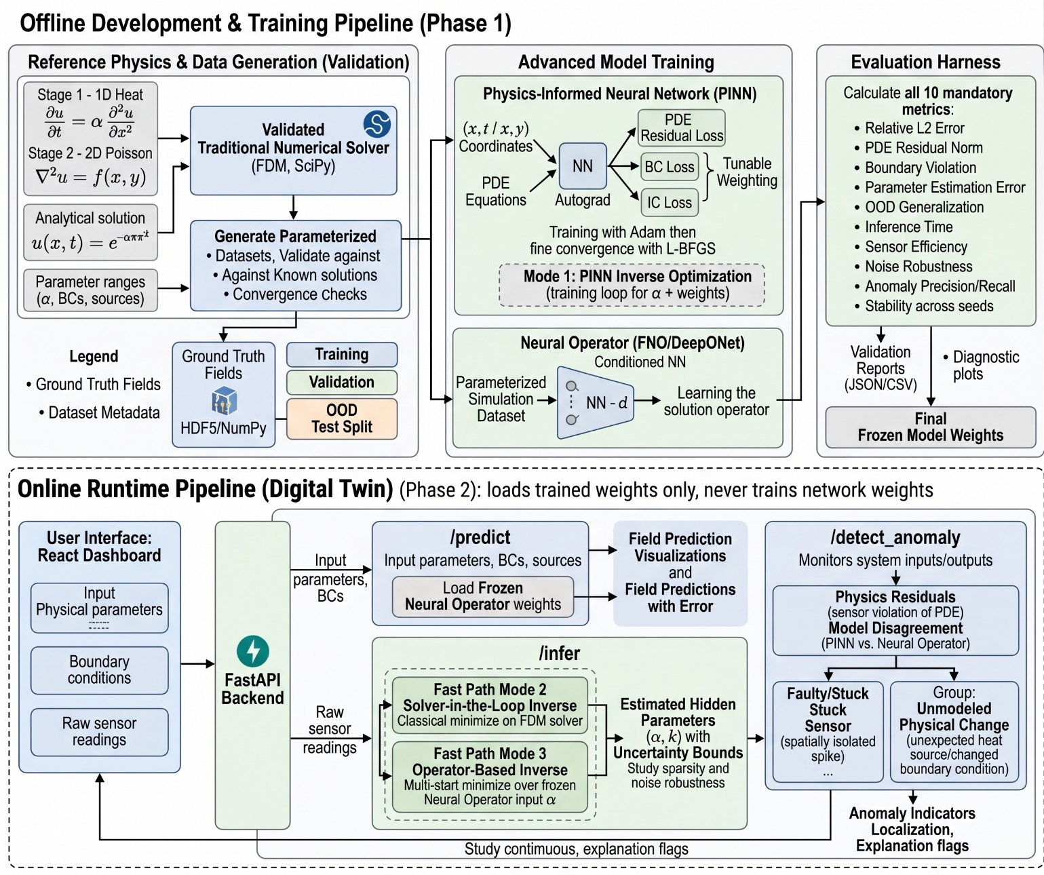

4. Technology Stack
Chosen to be practical for the given timeline while satisfying every engineering requirement in the brief (reproducibility, containerized deployment, separated training/eval/serving).
Component | Technology | Why
Numerical solver | Python + NumPy/SciPy (finite differences; sparse linear solve for 2D Poisson) | Transparent, easy to verify against the analytic solutions; no heavy dependency needed for these two problems.
PINN | PyTorch (autograd for PDE residuals), Adam + L-BFGS | Standard in the scientific ML community; native automatic differentiation for PDE residual losses; L-BFGS available as a built-in second-stage optimizer.
Neural operator | PyTorch; FNO or DeepONet, starting from a documented reference implementation | Implementing from the paper alone is a large lift in 8 weeks; adapting and materially extending an attributed reference implementation is explicitly allowed by the brief.
Experiment tracking | CSV/JSON logs + matplotlib, or MLflow/W&B if richer dashboards are wanted | Brief requires machine-readable results and reproducibility, not a specific tool.
Config & reproducibility | YAML configs, fixed random seeds, Git | Directly satisfies the brief's reproducibility and version-control requirements.
Backend/API | FastAPI (Python) | Lightweight, integrates directly with PyTorch models already in Python.
Dashboard/UI | React | Interactive scientific dashboard with minimal code, realistic given the many other deliverables.
Testing | pytest (solver verification, regression tests) | Supports the “reproducible from a fresh clone” requirement.

5. Implementation Approach, by Component

5.1 Numerical Reference Solver
- Implement finite-difference schemes: explicit/implicit time-stepping for the 1D heat equation, and a direct or iterative sparse linear solve for the 2D Poisson equation.
- Verify convergence against the exact analytic solutions given in the brief (Stage 1 and Stage 2) before trusting the solver for any other case.
- Respect the stability limit for explicit time-stepping (a CFL-type condition linking the time step, grid spacing, and α) to avoid numerical blow-up, especially once α becomes variable.
- Extend the solver to accept a parameterized family: varying α, boundary condition values/shapes, and source terms, to generate the training dataset.

5.2 Dataset Generation
- Sweep the solver across a defined distribution of α values and boundary condition shapes (and, if confirmed with the lead, initial conditions and source terms) to build a parameterized simulation dataset.
- Store each run with full metadata (parameter values, BC type, grid resolution, solver settings) in a structured format (e.g., NumPy/HDF5 arrays).
- Reserve a held-out split of parameter values/boundary shapes purely for out-of-distribution (OOD) generalization testing, kept separate from anything used in training or hyperparameter tuning.

5.3 Baseline Models
- Implement at least three simple baselines before any advanced model: e.g., nearest-neighbor/linear interpolation of sparse sensors, a plain feedforward neural network trained on solver-generated input/output pairs, and a simple regression model on hand-crafted features.
- These establish a credible lower bound so that PINN and neural-operator improvements can be measured, not assumed.

5.4 Physics-Informed Neural Network (PINN)
- Network takes coordinates (x,t) or (x,y) and later the physical parameter itself — as input and outputs the predicted field value.
- Three loss terms computed via automatic differentiation: PDE residual loss (collocation points sampled through the domain), boundary-condition loss, and initial-condition loss, combined with tunable weights.
- Train with Adam first, then switch to L-BFGS for fine convergence, per the brief's requirement.
- Run a documented study comparing activation functions, collocation/sampling schemes, and loss-weighting strategies, with residual/error curves as evidence.

5.5 Neural Operator (FNO / DeepONet)
- Train on the parameterized dataset (supervised, using solver output as ground truth) to learn a mapping from boundary conditions/parameters/source terms directly to the full solution field, in one forward pass.
- Evaluate specifically on the held-out OOD split to measure generalization to unseen parameters/boundaries without retraining this is a mandatory acceptance criterion in the brief.
- Compare against the PINN and the data-only baseline on identical test cases using the same metrics.

5.6 Inverse Problem (Hidden-Parameter Estimation)
Given sparse, noisy sensor readings and known boundary/geometry information, the system estimates the hidden parameter(s) by finding the value that makes the model prediction best match the observed sensor values. Three inversion modes are implemented and compared, each with a clearly defined role. Inference-time optimization over one or a few scalar parameters is distinct from training network weights: only the training-time PINN mode below runs a full training loop.
- Mode 1 — PINN inverse (offline): the hidden parameter (e.g., α) is a learnable scalar optimized together with the network weights, using PDE, boundary/initial and sensor-data losses. This is a training loop, so it runs offline for identifiability studies, the parameter-error study, and as a physics-faithful reference. It is not on the live request path.
- Mode 2 — Solver-in-the-loop inverse: classical least-squares fitting (e.g., SciPy) of the parameter against the finite-difference solver. For the 1D heat problem one solve takes milliseconds, so this is fast enough for runtime use and serves as a strong classical baseline.
- Mode 3 — Operator-based inverse (runtime fast path): with the trained neural operator frozen, optimize the parameter input by gradient descent or scipy.optimize.minimize so the predicted field matches the sensors. Use multiple starting points because the loss surface can have local minima. Prerequisite: the parameter (e.g., α) must be an input of the operator during training; if only boundary conditions are varied, this mode is impossible.
For all modes, report uncertainty, not just a point estimate: for example a profile-likelihood curve over the parameter, repeated fits with different noise draws or starting points, or an ensemble. Study how it changes with sensor count, sensor placement and noise level, as the brief requires. Sensitivity is worth noting for Stage 1: the field depends on α through exp(−απ²t), so readings at very early times carry little information about α and later times carry more.
- Hidden parameter for Stage 2 (to be confirmed): the fixed Poisson equation −∇²u = f(x,y) has no coefficient. Candidate hidden quantities that keep the equation unchanged are the source amplitude, source location and boundary values. An optional extension −k∇²u = f with scalar k (k = 1 reproducing the mandated problem exactly) would only be added if the lead approves. Note that with zero boundaries the solution scales as f/k, so k and the source amplitude cannot both be unknown: only their ratio is identifiable.

5.7 Sensor Simulation & Placement
- Simulate realistic point sensors: sample the solver's field at a small number of (x,t) or (x,y) locations, representing e.g. thermocouples on a rod or probes on a plate.
- Add measurement noise (tunable Gaussian noise) and inject sensor faults (stuck/constant readings, dropouts, biased offsets).
- Compare random, uniform, and information/error-driven sensor placement strategies, measuring how estimation/reconstruction error changes with sensor count and placement strategy.

5.8 Anomaly / Fault Detection
- Compute physics residuals (how much a sensor's reading disagrees with the model's physics-consistent prediction) and model disagreement (e.g., PINN vs. neural operator predicting meaningfully different fields for the same input) as the two core detection signals.
- Detect at least two distinct anomaly/fault types, as required: for example, a faulty/stuck sensor versus an unmodeled physical change (unexpected heat source or changed boundary condition).
- Report precision/recall for fault detection against known injected faults in the test data.

5.9 Evaluation Harness & Metrics
The harness computes, for every model on every test case, the following metrics (all explicitly required):
- Relative L2 field error
- PDE residual norm
- Boundary/initial condition violation
- Unknown-parameter estimation error
- Generalization error on unseen boundary/parameter settings
- Inference/training time
- Sensor efficiency (error vs. number of sensors)
- Noise robustness curve
- Anomaly/fault detection precision/recall
- Stability across random seeds
The harness runs as a single repeatable command producing both machine-readable (JSON/CSV) and human-readable (chart) output, satisfying the reproducibility requirement.

5.10 API & Dashboard
- FastAPI backend exposing /predict, /infer, and /detect_anomaly endpoints. /predict is a forward pass of the frozen neural operator. /infer runs the operator-based (or, for 1D, solver-based) inversion from Section 5.6 with multi-start optimization and returns the parameter with an uncertainty range. The PINN inverse is an offline study and is not called by the API. The runtime path loads trained weights only and never trains network weights.
- React dashboard where a user enters parameters/boundary conditions and/or sensor readings, and receives the predicted field, inferred parameters with uncertainty, error metrics, and anomaly flags with a short explanation of which sensor or region triggered them.

6. Known Risks, Edge Cases & Limitations
Identified up front so they are designed for, not discovered late:
- Invalid/contradictory boundary conditions: must be validated and rejected before inference, not silently solved incorrectly.
- Too few sensors: the inverse problem can become unidentifiable (multiple parameter values fit equally well); the system must report high uncertainty rather than a falsely confident estimate.
- Out-of-distribution parameters/boundaries: both PINN and neural operator degrade outside their training range; this must be measured and documented, not hidden.
- Numerical instability: explicit time-stepping for the heat equation has a stability limit tied to grid spacing and α; this must be checked, especially once α is variable.
- Sensor faults vs. genuine physical anomalies: these must be distinguishable outcomes, not conflated into a single “something is wrong” flag.
- Model overconfidence: the system should express low confidence / refuse to give a single confident answer for OOD inputs or unidentifiable inverse problems, rather than always returning one confident number.
- Non-convex or non-identifiable inversion: the fit of the hidden parameter can have local minima or a flat valley (for example k and source amplitude in the Poisson problem, or α with only very early-time readings). Mitigated by multi-start optimization, uncertainty reporting and refusing to return a confident value when the fit is flat.
- PINN training instability: a known failure mode in the field, driven by poor loss weighting or collocation sampling; mitigated by the mandated optimizer/activation/sampling study.

6. Open Questions for Confirmation Before Implementation
- Which physical parameter(s) exactly should be hidden for the inverse problem α only, or others as well?
- For Stage 2 the given PDE has no coefficient. May a scalar conductivity k be added (with k = 1 recovering the given equation), or should the hidden quantity be the source term or a boundary value?
- What range/distribution of α and boundary-condition shapes should the parameterized dataset and neural operator training cover?
- Does the initial condition also vary across the training distribution, or stay fixed while only α/boundary conditions vary?
- What sensor counts and noise levels should be treated as the standard test grid?
- How much extension of an existing FNO/DeepONet reference implementation counts as “materially extended”?

7. Conclusion
This plan implements every required component of the brief validated numerical solver, PINN, inverse-parameter estimation, neural operator, sensor/anomaly module, and a digital twin interface using a practical, well-understood technology stack (Python, PyTorch, FastAPI, React), built in the sequence and against the gates defined in the delivery plan. The architecture explicitly separates training-time work from the runtime product, and every stage produces the specific measurable evidence required for that stage's gate, so that progress and failure points are documented rather than discovered only at the final hidden benchmark.

